Your Book Title
Enter Book Subtitle Here – You can delete this line if you wish to not have a subtitle

AUTHOR NAME
RK Publications

RK Publications
Published Globally
1STEdition - 2026
ISBN xxx-x-xxxxx-xx-x
This book has been published with all reasonable efforts taken to make the material error-free after the consent of the author. No part of this book shall be used, reproduced in any manner whatsoever without written permission from the author, except in the case of brief quotations embodied in critical articles and reviews.
The Author of this book is solely responsible and liable for its content including but not limited to the views, representations, descriptions, statements, information, opinions and references [“Content”]. The Content of this book shall not constitute or be construed or deemed to reflect the opinion or expression of the Publisher or Editor. Neither the Publisher nor Editor endorse or approve the Content of this book or guarantee the reliability, accuracy or completeness of the Content published herein and do not make any representations or warranties of any kind, express or implied, including but not limited to the implied warranties of merchantability, fitness for a particular purpose. The Publisher and Editor shall not be liable whatsoever for any errors, omissions, whether such errors or omissions result from negligence, accident, or any other cause or claims for loss or damages of any kind, including without limitation, indirect or consequential loss or damage arising out of use, inability to use, or about the reliability, accuracy or sufficiency of the information contained in this book.

Price - INR ₹ 800 | USD $10 Head office -Saravanampatti

Coimbatore, India

Dedicated to our family members.
Contents
To update the Table of Contents, please right-click the field and choose ‘Update Field’ and ‘Update Entire Table.’ When you update the Contents field, the fonts would automatically change to the default ‘Calibri’ setting given by Word. You can manually select the text and change the font to ‘Gandhi serif.’ Please delete these instructions once you update the Table of Contents. For more details, please go through the Reference Guide.
Foreword vii
Preface ix
Acknowledgments xi
Prologue/Introduction xiii
1. Enter Chapter name 1
Sample Subheading 1
2. Enter Chapter Name 3
3. Enter Chapter Name 5
4. Enter Chapter Name 7
5. Enter Chapter Name 9
Epilogue 11

Foreword
A Foreword is a short introduction to the book, usually by a person other than the author. The purpose of the Foreword is to introduce the author or his/her work.
A Foreword could talk about why the book’s content is relevant in its current scenario or how it created a historical impact when it was first released or the importance of the author’s work.
As you can see here, the first paragraph is usually given a flush left alignment (Normal_without indent) and all subsequent paragraphs are given a slight indent (Normal_indent). The first paragraph of a new section after a subheading should also be given a flush left alignment. This rule applies to all chapters in the book.
Headers in the front matter of the book contain the name of the chapter alone. Pages in which the chapter starts would not have headers or footers.
The Foreword is usually signed by its writer with his/her credentials and the date. You can delete this page if you do not wish to include a Foreword in the book.
Name of the author of the Foreword
Credentials
Date

Preface
The Preface is an introductory passage to the book, which is written by the author. It could talk about how the story came into being, the purpose of the book, its main characters, the author’s journey of writing the book, etc.
As you can see here, the first paragraph is usually given a flush left alignment (Normal_without indent) and all subsequent paragraphs are given a slight indent (Normal_indent). The first paragraph of a new section after a subheading should also be given a flush left alignment. This rule applies to all chapters in the book.
Headers in the front matter of the book contain the name of the chapter alone. Pages in which the chapter starts would not have headers or footers.
The Preface is usually signed by the author with the date. You can delete this page if you wish to not include a Preface in the book.
We’ve added additional text in this section to show you how the headers and footers appear in the subsequent pages. Please delete the instructions and the additional text when you add the actual content of the book.
Author name
Date

Acknowledgments
The Acknowledgments page is usually written by the author to publically thank people who have contributed to the book.
Acknowledgments in some books run on for pages, but it is generally considered good practice to limit this section to a page, so that readers are not tempted to overlook it entirely.
As you can see here, the first paragraph is usually given a flush left alignment (Normal_without indent) and all subsequent paragraphs are given a slight indent (Normal_indent). The first paragraph of a new section after a subheading should also be given a flush left alignment. This rule applies to all chapters in the book.
Headers in the front matter of the book contain the name of the chapter alone. Pages in which the chapter starts would not have headers or footers.
You can delete this page if you do not wish to include an Acknowledgments page in the book.
We’ve added additional text in this section to show you how the headers and footers appear in the subsequent pages. Please delete the instructions and the additional text when you add the actual content of the book.

Prologue/Introduction
A Prologue, in case of fiction books, can be an excerpt from the book or a section of the story that happens before the true beginning of the story. It could provide readers an introduction to the nature of the characters in the story, a view of events that happened earlier and also set the tone of the book.
An Introduction, in case of non-fiction books, defines what the book is about, what a reader can expect from the book, the motivation for the book and, sometimes, guidance on how to use the book.
As you can see here, the first paragraph is usually given a flush left alignment (Normal_without indent) and all subsequent paragraphs are given a slight indent (Normal_indent). The first paragraph of a new section after a subheading should also be given a flush left alignment. This rule applies to all chapters in the book.
Headers in the front matter of the book contain the name of the chapter alone. Pages in which the chapter starts would not have headers or footers.
You can delete this page if you do not wish to have a Prologue or Introduction in the book.

Enter Chapter name
You can start typing out or copy-pasting the first chapter of your book here.
The heading style ‘Heading 1’ can be used from the Quick Styles gallery for the chapter heading.
As with all other chapters, the first paragraph is given a flush left alignment. This style can be chosen from the Quick Styles gallery with the name ‘Normal_without indent.’ All subsequent chapters have a slight indent and this style can also be availed from the Quick Styles gallery with the name ‘Normal_indent.’
If you wish to insert a citation and reference as a footnote in a page, you can do so by placing the cursor where the citation number should be inserted and choosing ‘Insert Footnote’ from the References tab. This would add a citation number where the cursor is placed and a footnote in the same page. You can enter the reference text by clicking in the footnote.

Sample Subheading
If a chapter has a subheading, you can choose the style ‘Heading 2’ from the Quick Styles gallery to apply the heading style.
The headers used in Body text are ‘Book title’ on the left-side page and ‘Author name’ or ‘Chapter name’ on the right-side page. Pages in which chapters start would not have headers or footers.
At the end of every chapter, make sure to enter an Odd-page break. This makes sure that the next chapter starts on a right-side page. The Odd-page break can be found under ‘Breaks’ in the Page Layout tab. This has been added at the end of every chapter in the template.
We’ve added additional text in this section to show you how the headers and footers appear in the subsequent pages. Please delete the instructions and the additional text when you add the actual content of the book.

2. Enter Chapter Name
You can also add quotes in the book. Make sure to mention the name of the author though.
- Author name
You can enter the text of the second chapter here.
The headers used in Body text are ‘Book title’ on the left-side page and ‘Author name’ or ‘Chapter name’ on the right-side page. Pages in which chapters start would not have headers or footers.
You can also insert images inside the book. We’ve provided a sample here.
If you wish to print the images in color, be sure to insert color images with atleast a resolution of 300 dpi and choose the full-color option when you set up the book on the platform. Also, please note that making the book full-color would substantially increase the printing cost and, therefore, the MRP of the book.
If you have more than one image in the book, be sure to number the images.
Center-align the image and wrap text ‘Top and Bottom’ around the image.
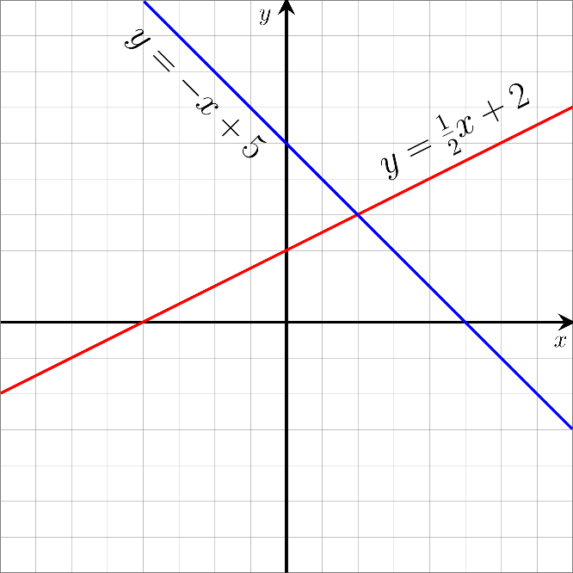
Fig. 1. You can also add a caption for each image. The style ‘Image_caption’ can be chosen from the Quick Style gallery to style the caption text.
We’ve added additional text in this section to show you how the headers and footers appear in the subsequent pages. Please delete the instructions and the additional text when you add the actual content of the book.

Enter Chapter Name
You can replace this text with the third chapter of the book here.
The headers used in Body text are ‘Book title’ on the left-side page and ‘Author name’ or ‘Chapter name’ on the right-side page. Pages in which chapters start would not have headers or footers.
We’ve added additional text in this section to show you how the headers and footers appear in the subsequent pages. Please delete the instructions and the additional text when you add the actual content of the book.

Enter Chapter Name
You can replace this text with the fourth chapter of the book here.
The headers used in Body text are ‘Book title’ on the left-side page and ‘Author name’ or ‘Chapter name’ on the right-side page. Pages in which chapters start would not have headers or footers.

Enter Chapter Name
You can replace this text with the fifith chapter of the book here.
The headers used in Body text are ‘Book title’ on the left-side page and ‘Author name’ or ‘Chapter name’ on the right-side page. Pages in which chapters start would not have headers or footers.
.

Epilogue
An Epilogue is the final chapter in a book and it provides an ending to the story. The plot of the Epilogue usually takes place after the main story has ended.
Headers in the end matter of the book contain the name of the chapter alone. Pages in which the chapter starts would not have headers or footers.
This section can be deleted if you do not wish to have an Epilogue in the book.
We’ve added additional text in this section to show you how the headers and footers appear in the subsequent pages. Please delete the instructions and the additional text when you add the actual content of the book.

Sample footnote

